1. <https://www.youtube.com/watch?v=4Wh22ynlLyk>

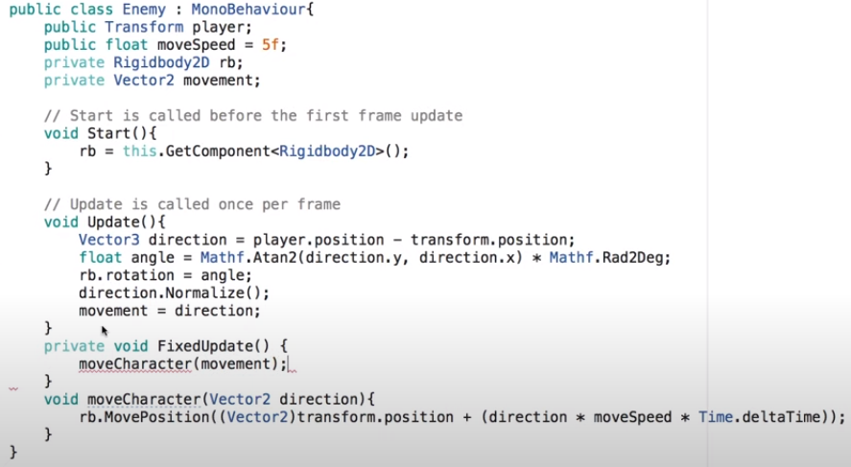



1. <https://www.youtube.com/watch?v=jq_TXQ8BGek>
2. <https://www.youtube.com/watch?v=rhoQd6IAtDo>

